EEOB 563 Final Project (Draft)

**Estimating divergence time of sponges using fossil records of primates’ mitochondrial genome under different evolutionary models**

**Introduction**

Classified as non-bilaterian animals, sponges (Phylum Porifera) play an important role in understanding the tree of life. Sponges are distributed into four distinct classes: calcareous sponges (Calcarea), glass sponges (Hexactinellida), demosponges (Demospongiae) and Homoscleromorpha.

With highly conserved regions, mitochondrial genome has been demonstrated as another powerful way of studying the evolutionary process. Pozzi has published a study of divergence dates of primates inferred from mitochondrial genomes (Pozzi, 2014).

Fossil records are widely used as one resource of studying evolutionary process of animals. With the help of new fossil records analyzed and the method of molecular clock, the divergence time of various species are being estimated. The fossil records of several species, especially primates have been well established by scientists across the globe. Unfortunately, due to the body structure and living condition, it is difficult for sponges to fossilize. So far, the fossil record of only one class of phylum Porifera (Hexactinellida) has been discovered and studied.

As there is barely any fossil record for other types of sponges and fossil record of primates have been well studied, for this project, I purposed estimating the divergence time of other sponge classes using the fossil record of primates’ mitochondrial genomes using molecular clock methods.

**Methods**

All sequences were downloaded from GenBank. Primates fossil record information used in this study were by retrieved from Pozzi’s study. The whole mitochondrial genome used in this study were concatenated by genome features (coding genes, rRNA subunits and tRNA)

The concatenated genomes were aligned using software MAFFT with default settings. Phylogenetic informative sites were selected by software G-Block. BEAST2 together with its included packages were used for implementing the molecular clock analysis.

The nucleotide substitution model was selected using software J-Model Test.

Four different molecular clocks and two tree models were used to select the optimal model: strict clock, relaxed clock exponential, relaxed clock log normal, random local clock, Fossilized Birth Death Model and Birth Death Model. Path sampling/stepping stone were used for calculating the marginal likelihood. The final model selection was made by cross comparing the Bayes factor of different models.

**Results**

From the figure shown below, we can see that the origination of sequences with fossil records was true to the date they were assigned; however, the estimated divergence dates did not match the given fossil records. It seems that all the divergence dates estimated were around 5 million year later. The divergence date of sponges estimated in this tree was around 2.5 million year.

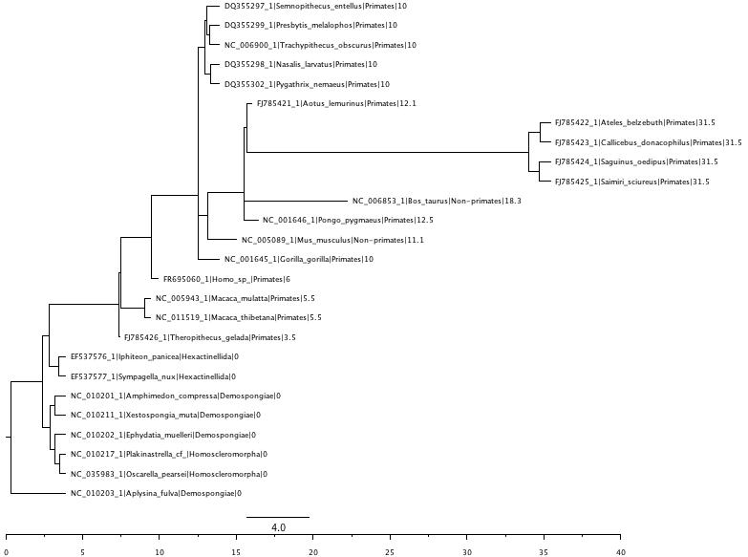

**Discussion**

The estimation of divergence date of sponges using primates’ fossil records was attempted. To complete the estimation entirely, quite a few steps are desperately in need along the way.

First, it is debatable to use primate’s mitochondrial genome to estimate the divergence of sponges. The pros are that primates were well studied with a fair good amount of fossil resources available. The cons, however, are also unneglectable: the evolutionary distance between primates and sponges are large; the mitochondrial genome organizations are quite distinct. Thus, it is important to have a high quality of test data. Adding more non-primate sequences with reliable fossil records can be one solution. However, as the mito-genome orientations vary among species to species, that selection process cannot be entirely random. Second, as stated above, the mito-genome orientations are various among species. It is reasonable to repeat the study using individual coding genes or rRNA. Third, the model selection is conducted by comparing the Bayes factors of different models. That comparison, however, did not count for the interactions of priors inside each model.

Pozzi, L., Hodgson, J. A., Burrell, A. S., Sterner, K. N., Raaum, R. L., & Disotell, T. R. (2014). Primate phylogenetic relationships and divergence dates inferred from complete mitochondrial genomes. *Molecular Phylogenetics and Evolution,75*, 165-183. doi:10.1016/j.ympev.2014.02.023